The AWS Command Line Interface (AWS CLI) is a unified tool to manage your AWS services. With just one tool to download and configure, you can control multiple AWS services from the command line and automate them through scripts.

**Amazon S3**

Amazon Simple Storage Service (Amazon S3) is an object storage service.

 You can use Amazon S3 to store and retrieve any amount of data at any time, from anywhere.

**What is an S3 Bucket?**

S3 stands for simple storage service, and it is AWS's cloud storage service.

S3 provides the ability to store, retrieve, access, and back up any amount of data at any time and place.

As S3 is object-based storage, this means that all data is stored as objects.

**Boto3**

Boto3 is the name of the Python SDK for AWS.

It allows you to directly create, update, and delete AWS resources from your Python scripts.

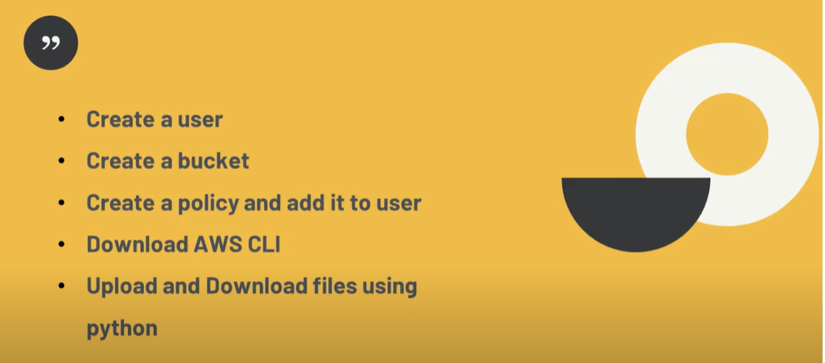

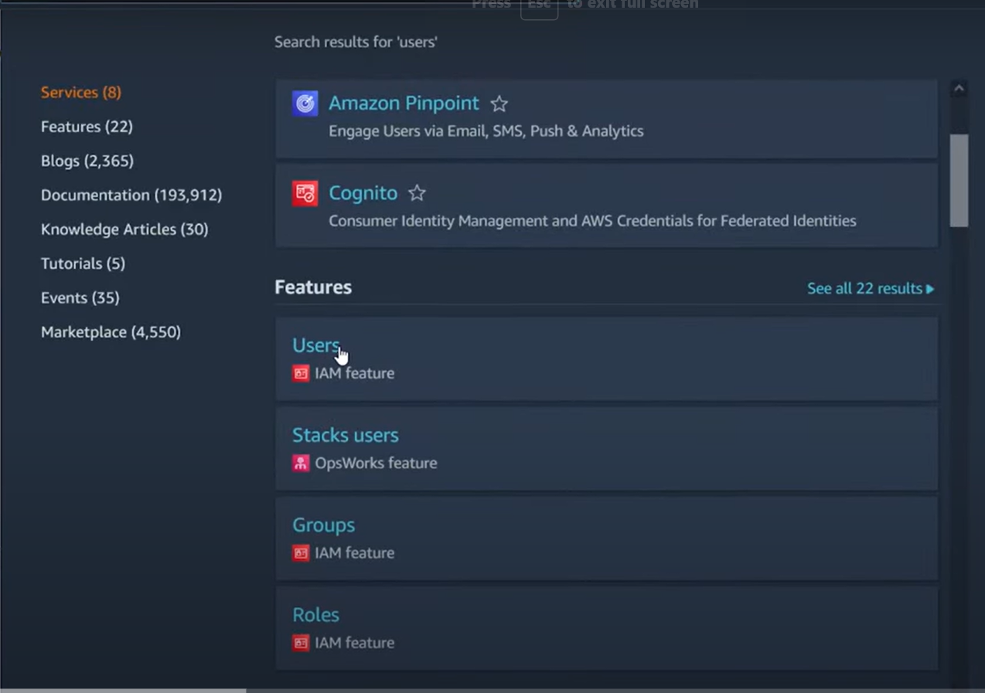

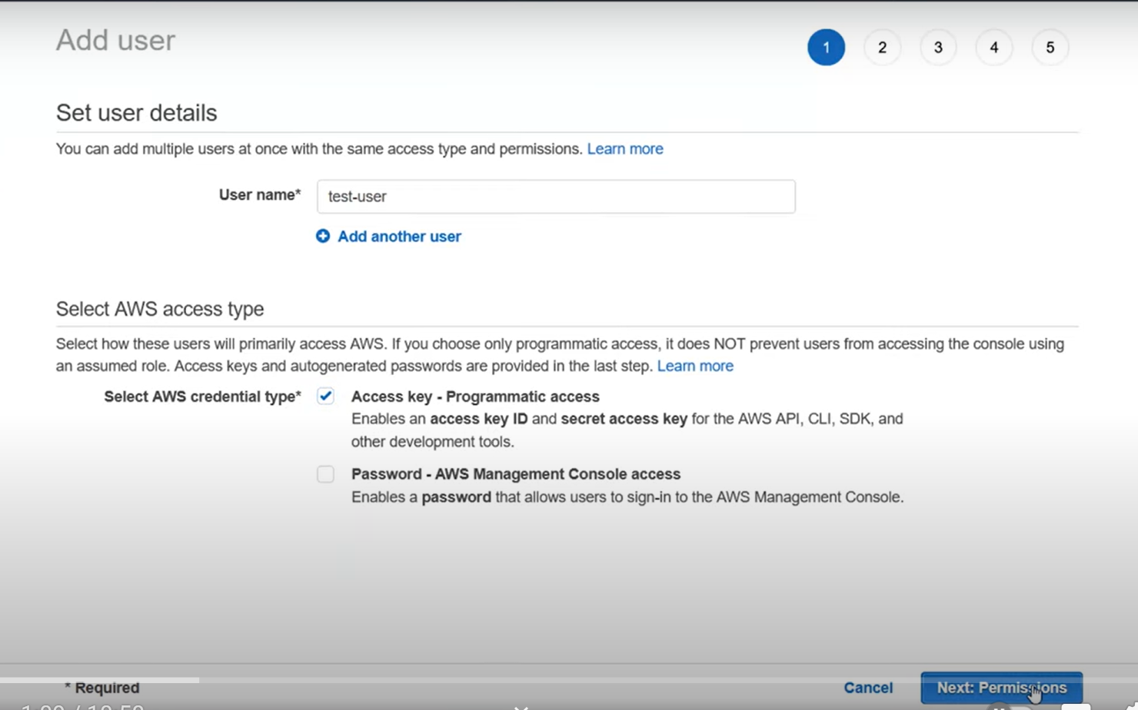

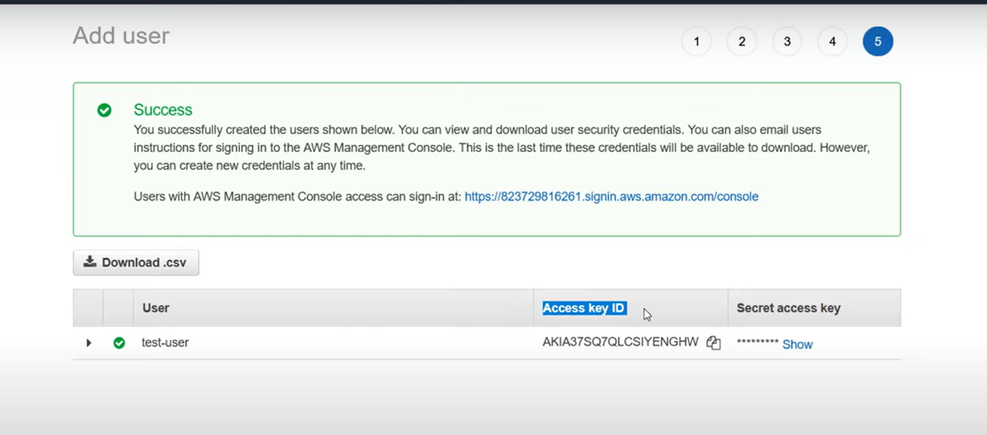 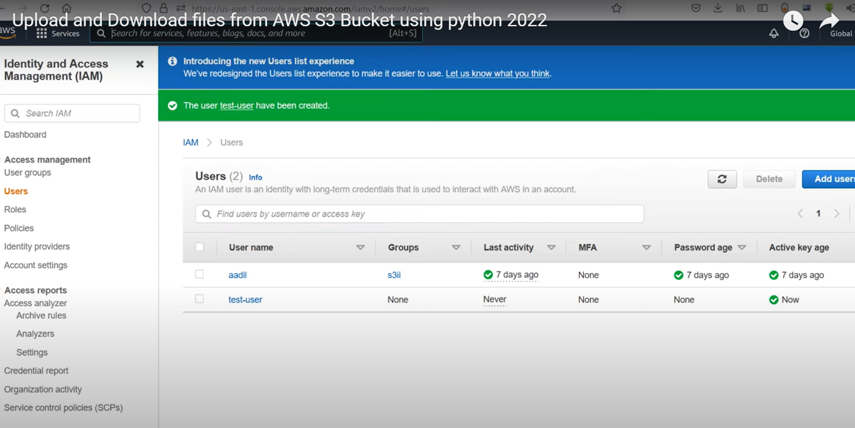

Need to Create Bucket

Search for S3

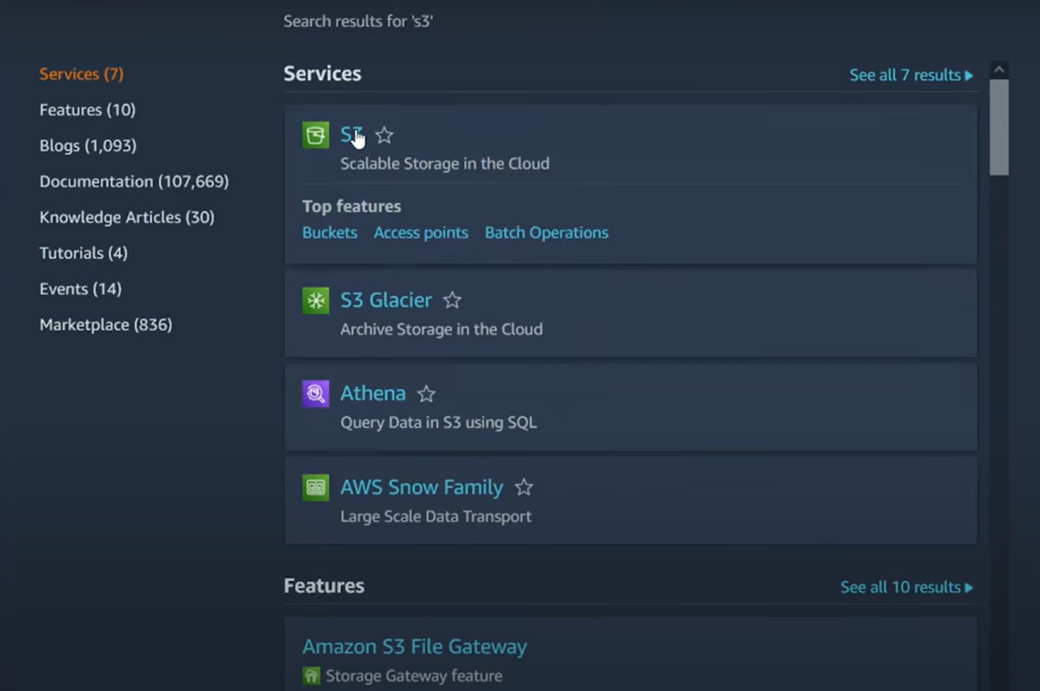

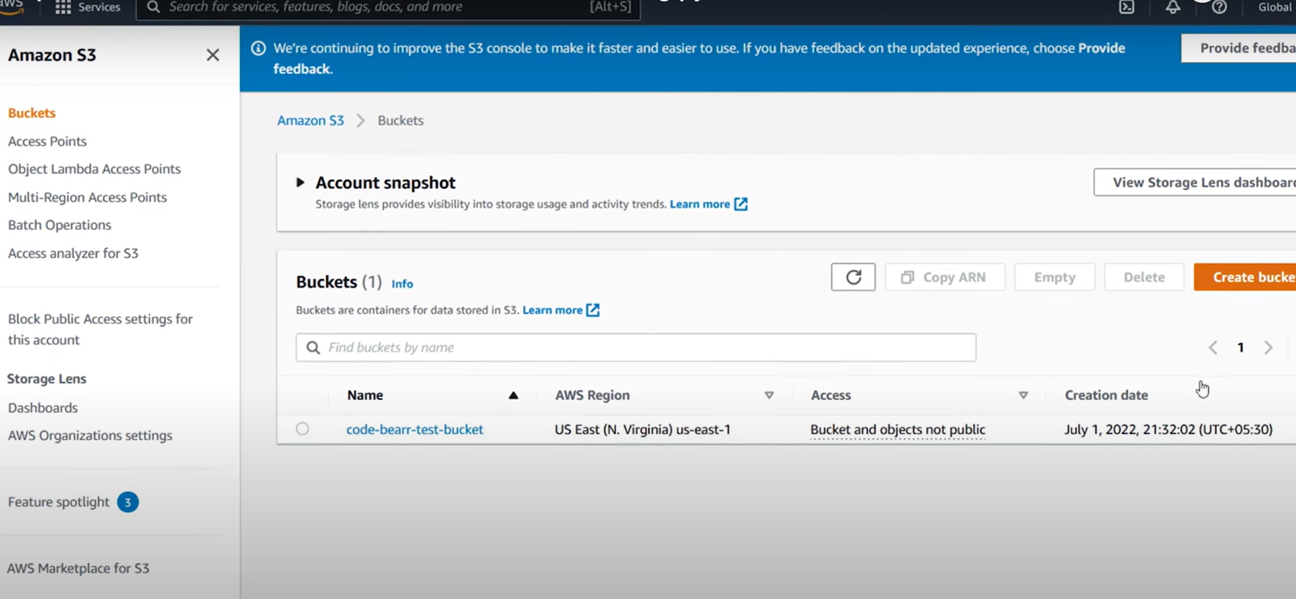

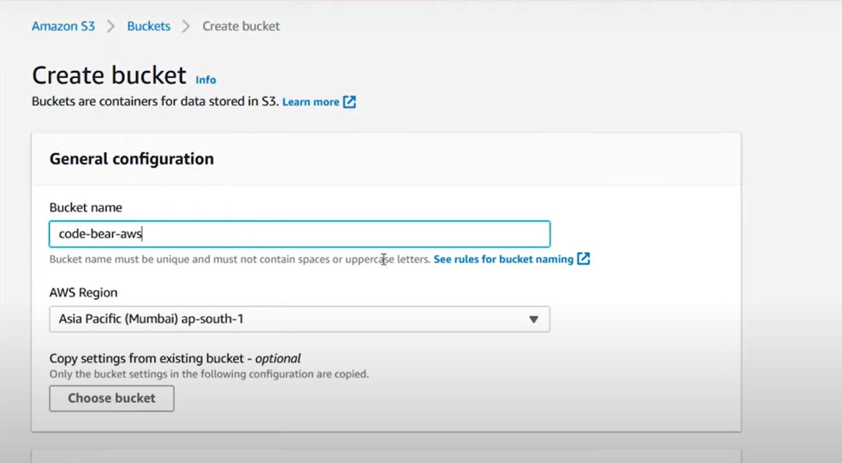

**Create Folder for upload Files**

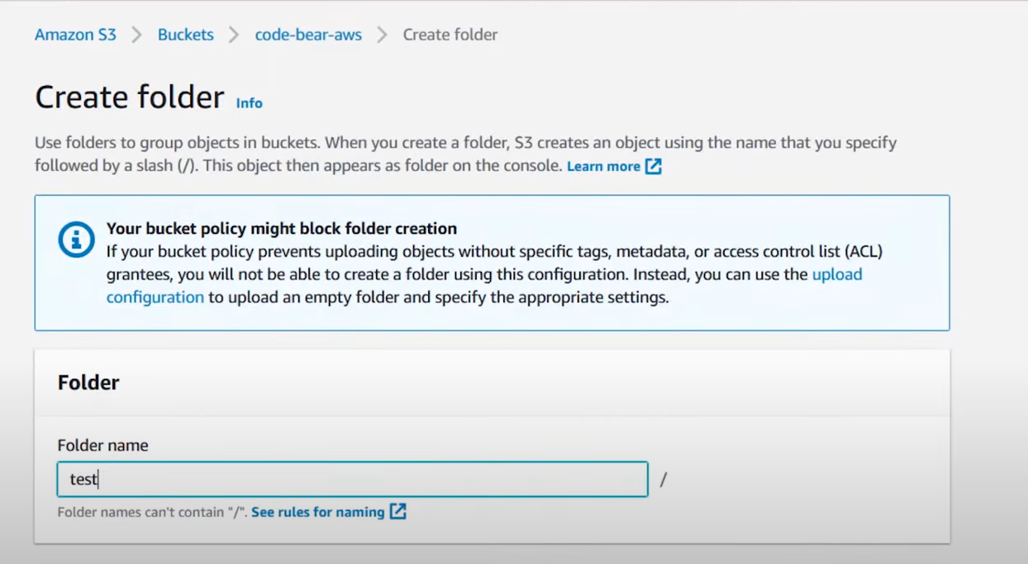

Manual Upload File

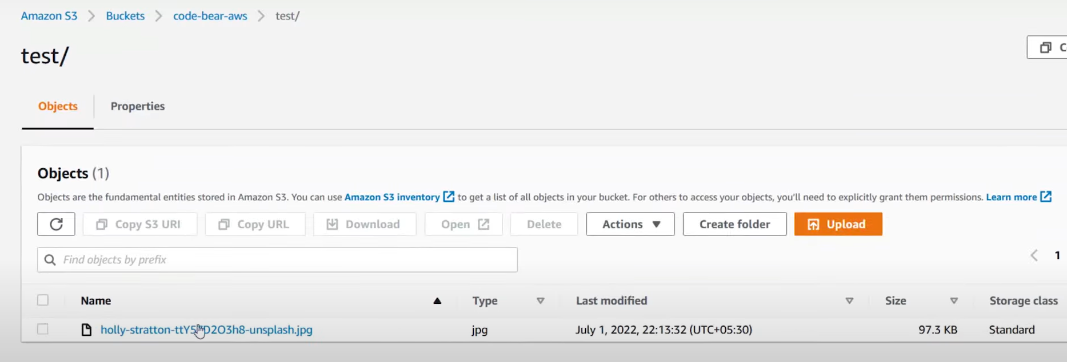

Policies

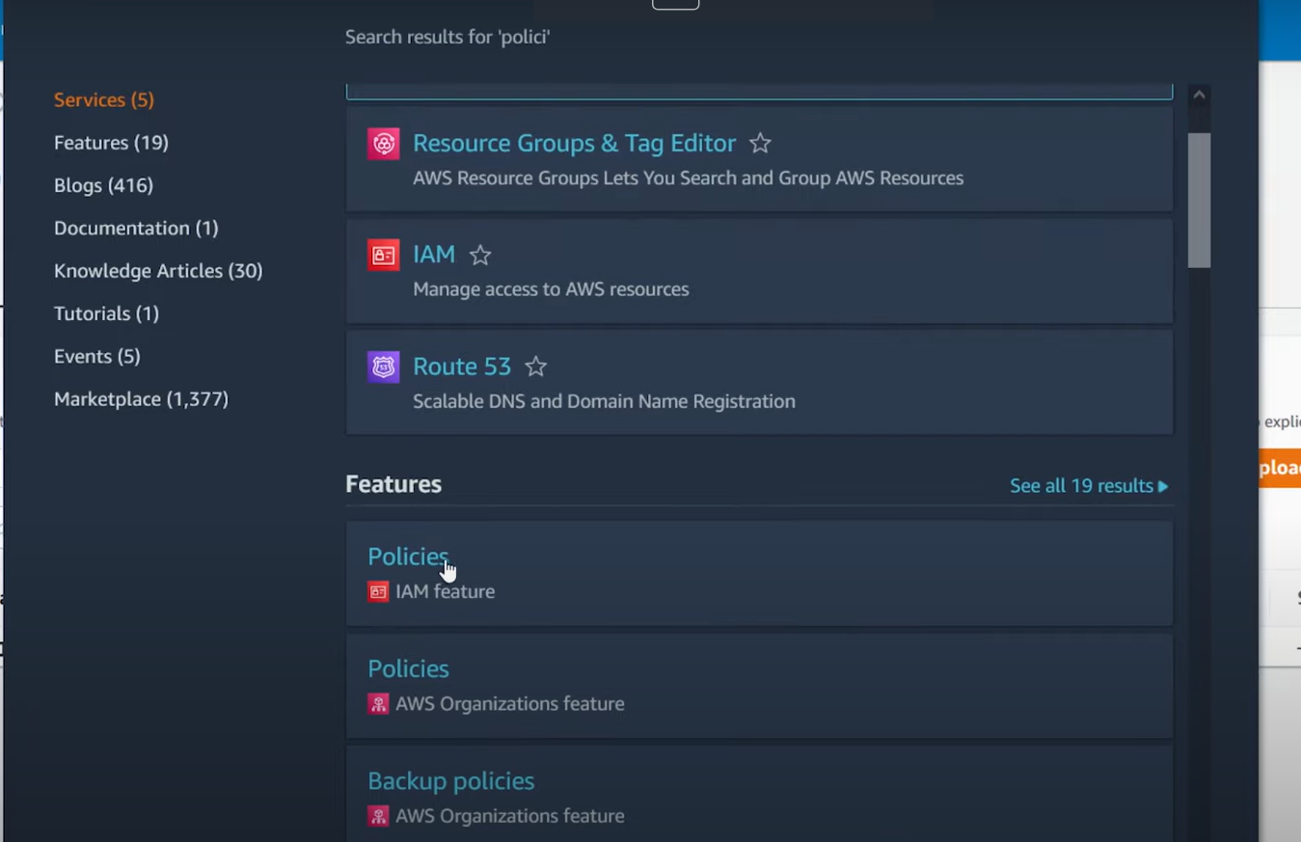

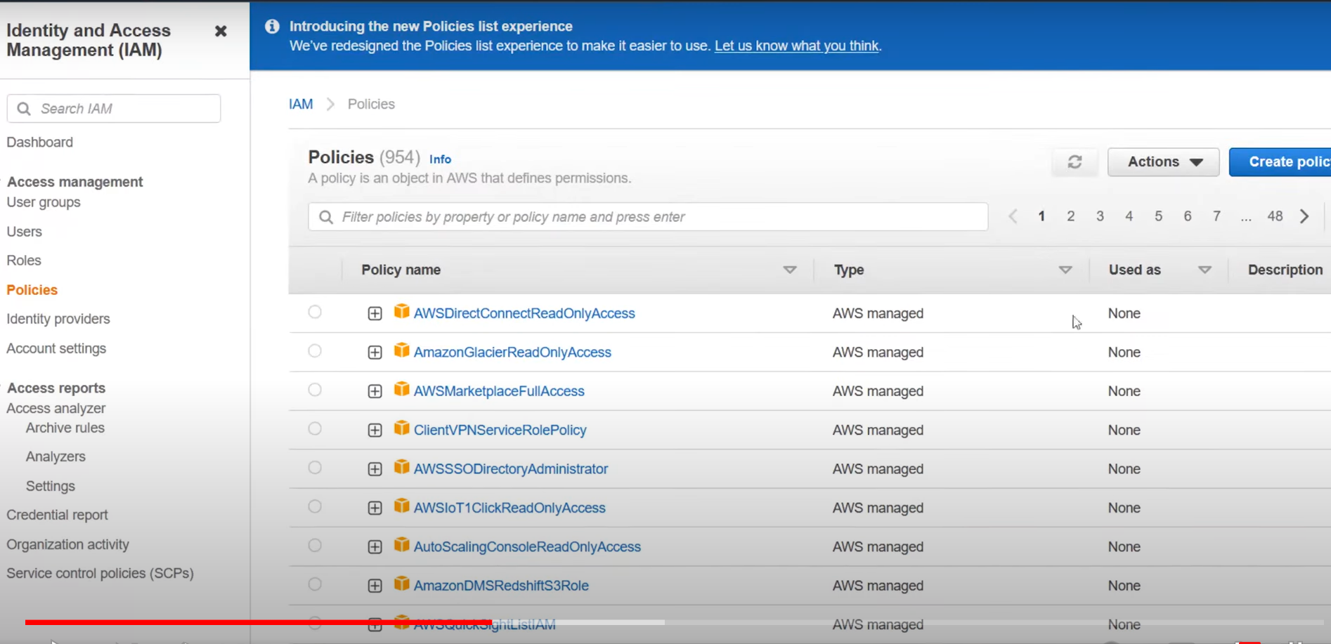

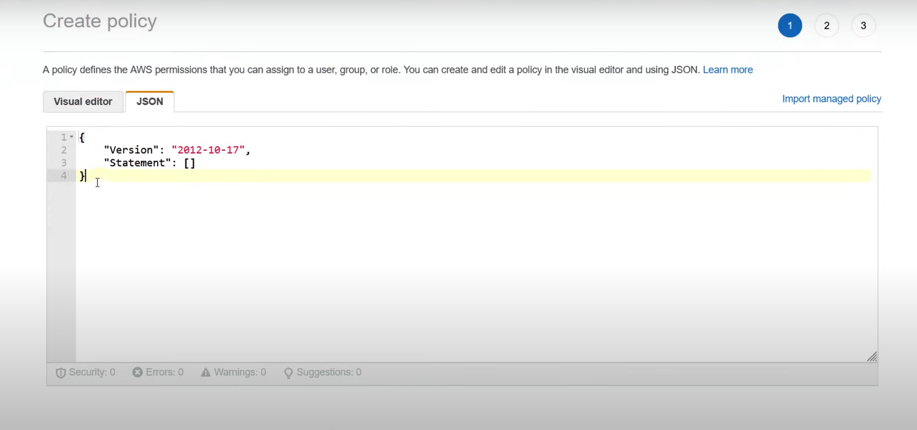

Modify JSON

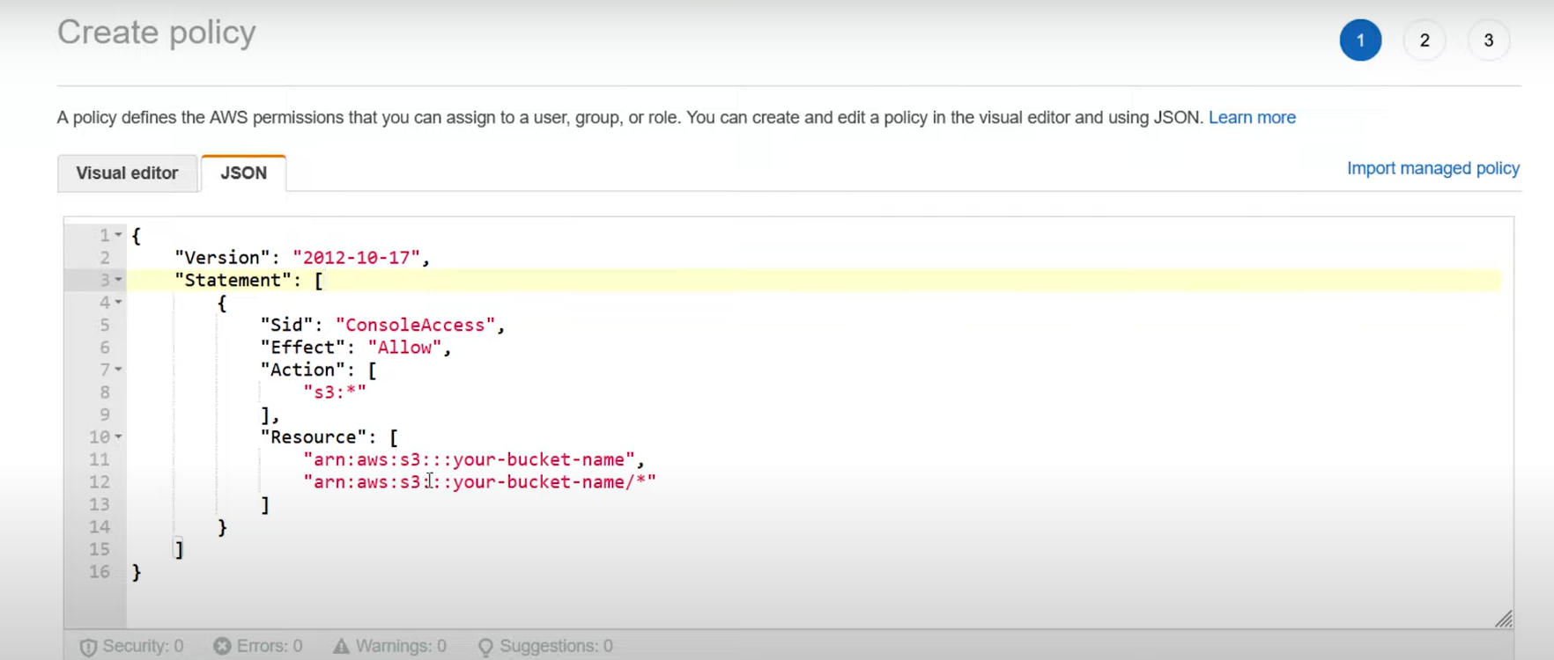

Replace Created Our Bucket Name and Path

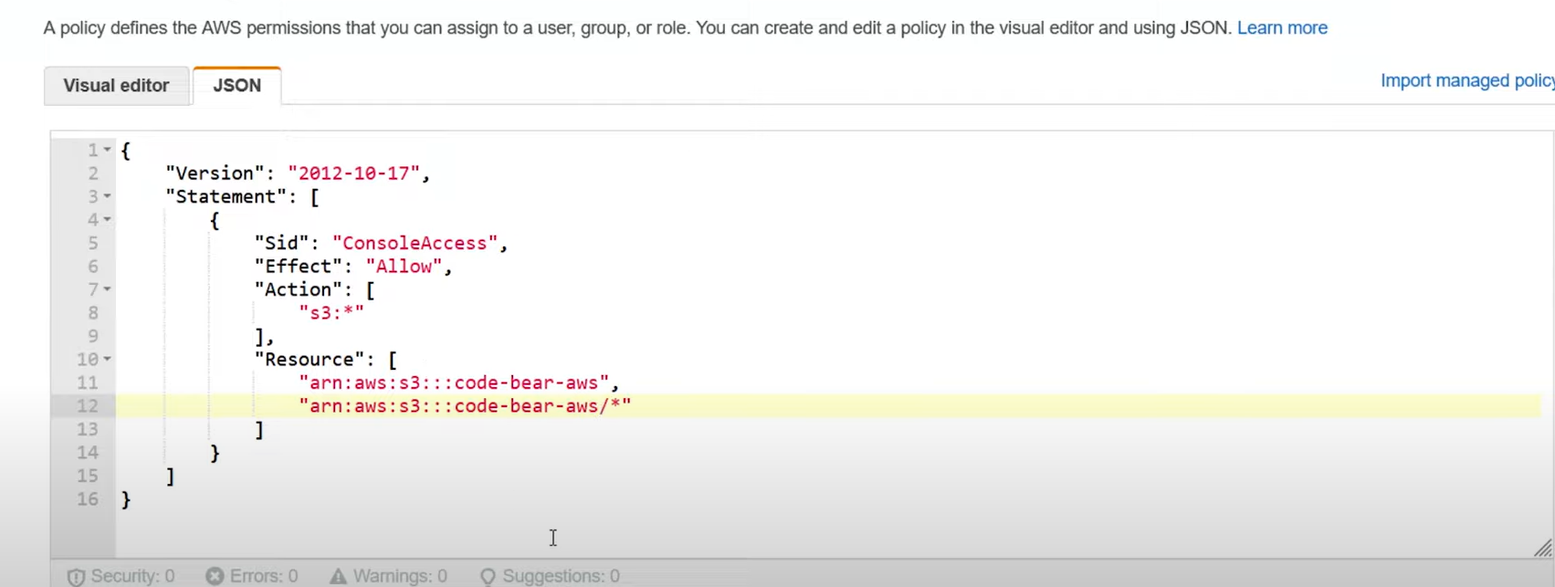

Next-.. Next

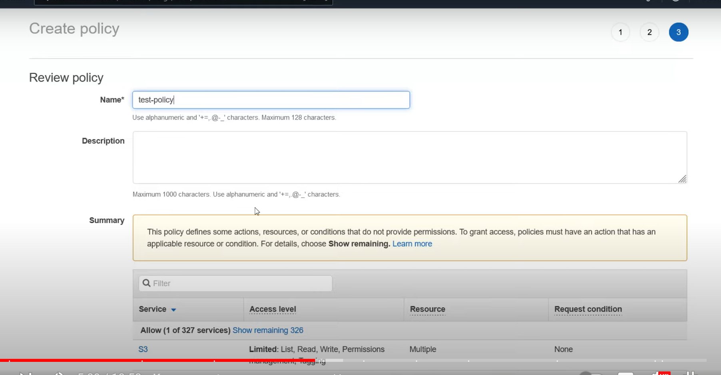

Add Permission

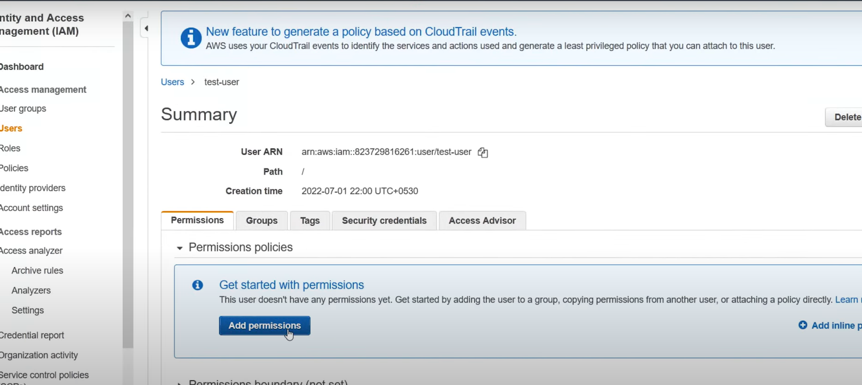

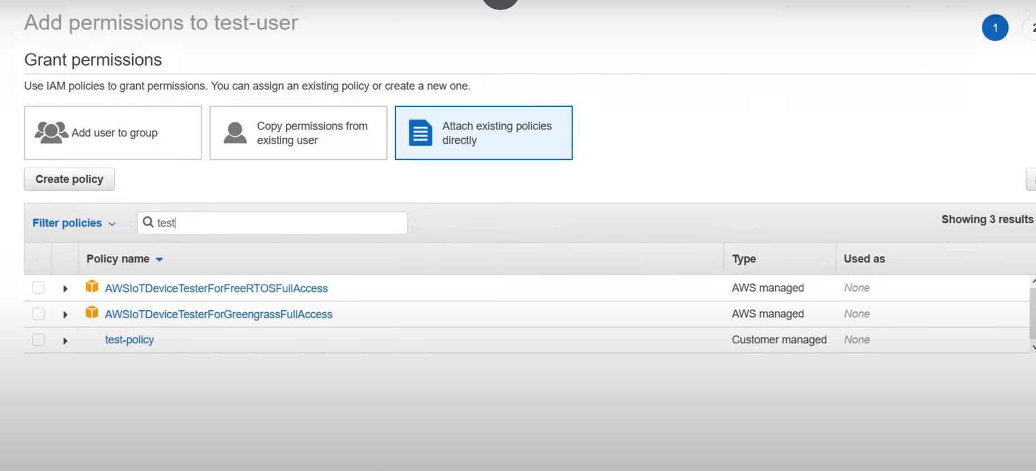

# Select Policy and Add Policy

Download and Install AWS CLI

After that From files

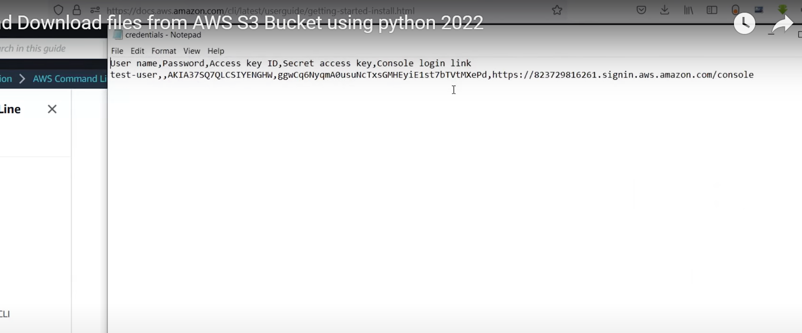

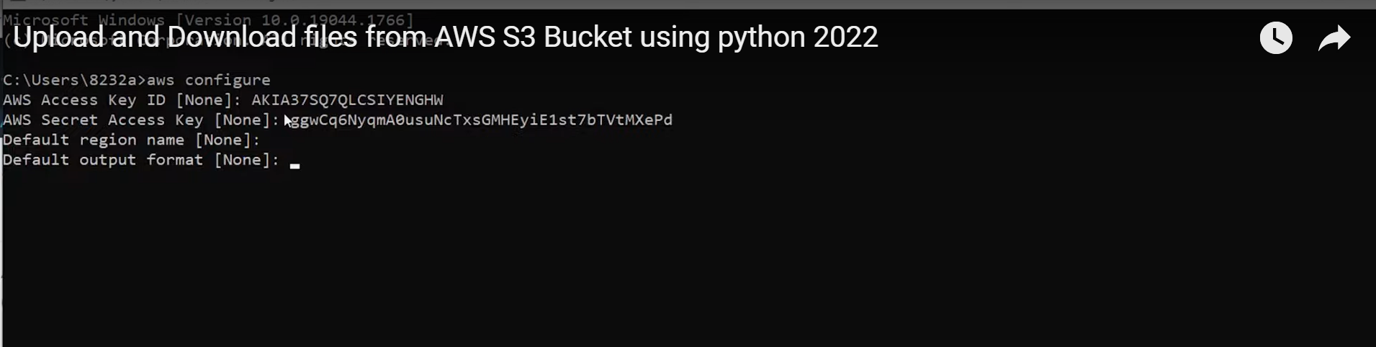

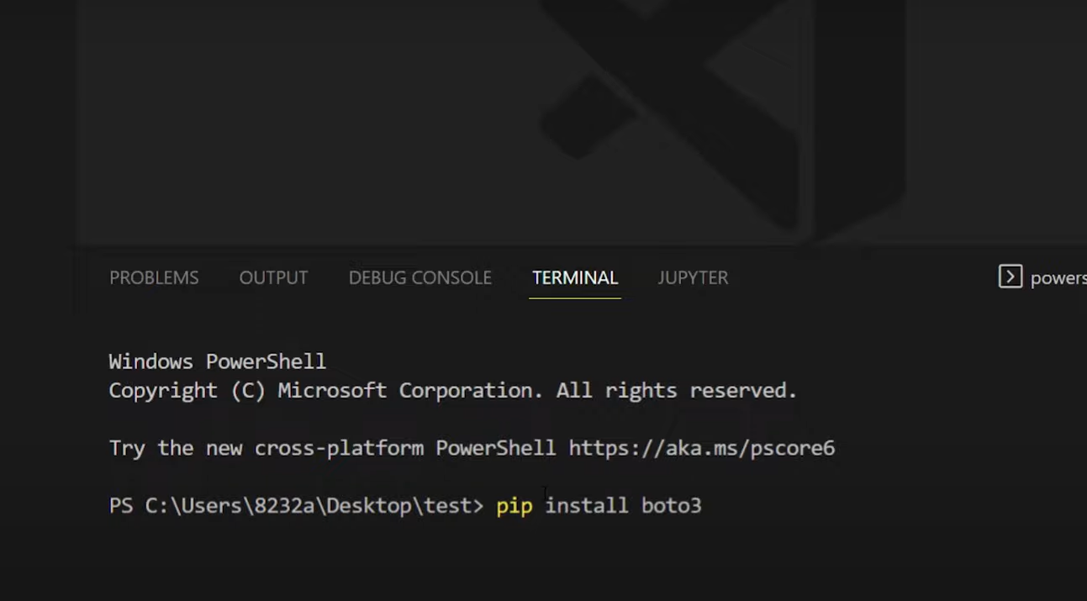

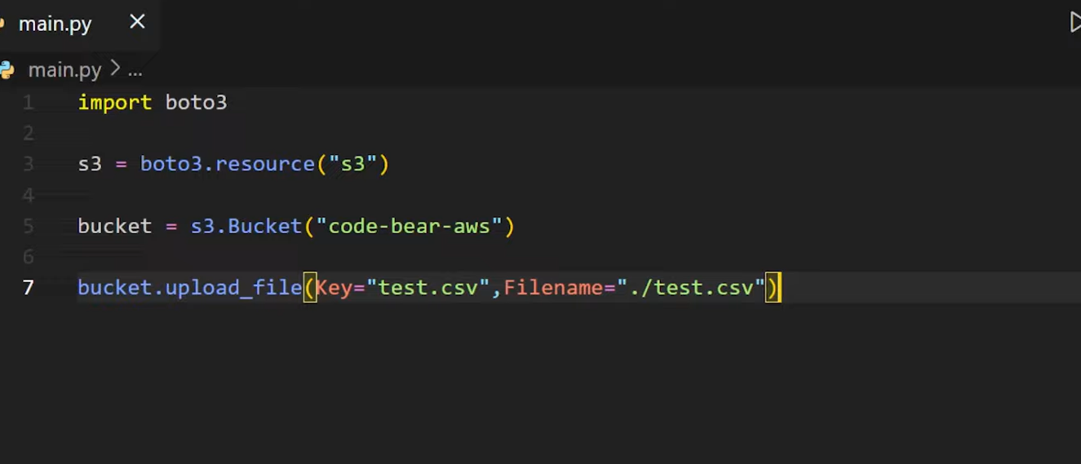

Run this File

Download Files

